Operation GaliWatch

Inspired by Toke Høye’s PollinatorWatch (hosted by Zooniverse www.zooniverse.org), we are setting up time-lapse cameras to gather thousands of images of pollinators visiting two common native flowering plants, salal and dull Oregon grape, at a mid-island location on Galiano Island, British Columbia. We plan to automate the analysis of the images to document the number and type of pollinator visitors we get.

In addition, we have set up a weather station and particulate matter sensor to gather hyperlocal weather and air quality data in the immediate vicinity of our cameras. The particulate matter sensor should give us an estimate of pollen count and detect smoke in the air from wildfire drift.

The images will be a window to the day-to-day ins and outs of Galiano pollinators that will help us better understand how wildflowers and pollinators are affected by local weather events.

Knowledge gaps we might help fill 😊

It’s well known that bees are important wildflower pollinators; however, many non-bee insects including wasps, hover flies, other flies, beetles, and butterflies also visit flowering plants and are often overlooked in pollinator monitoring studies. Although these non-bee visitors deposit a lot less pollen per visit, they can make up for it by visiting much more frequently. Local surveys of bee species that pollinate salal and dull Oregon grape report that bumble bees are the primary pollinators, with other bee species visiting less frequently (J.Wray & E. Elle, SFU Pollination Ecology Lab www.sfu.ca/people/eelle/bee_info.html).

Our images and data analysis will help provide baseline data on:

1. Initiation of flowering of salal and dull Oregon grape, and estimates of floral resources over the flowering season
2. Pollinator community composition attracted to salal and dull Oregon grape at our location (bees, hoverflies, butterflies, wasps, other flies, beetles)
3. Time of emergence and seasonal abundance of different pollinators
4. How much of a role, if any, non-bee visitors play in the pollination of these two flowering plants
5. How hyperlocal weather and variations in air quality influence the activity of wild pollinators.

The images and weather data will add to what is already known about pollinators in Coastal Douglas fir ecosystems here on the west coast of British Columbia and provide additional information about pollinator behaviour both throughout the day and day-to-day while plants are in bloom.

Galiano Island

Galiano is the long narrow island of the Southern Gulf Island chain on the west coast of British Columbia. Located within the Coastal-Douglas Fir biogeoclimatic zone, it has a semi-arid ecosystem characterized by a mild climate with cool wet winters and warm dry summers, with annual drought conditions typically from mid-June to early October.

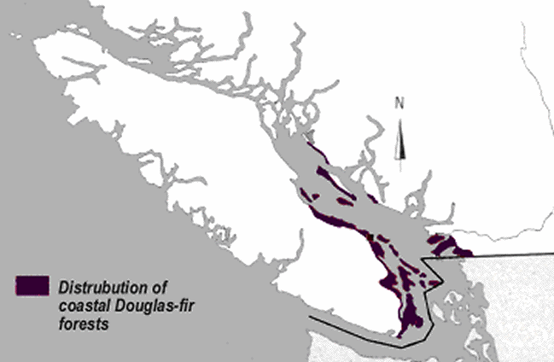

Galiano

<http://galianostory.com/FLORAFAUNA.HTM>

Bee species, non-bee species and other pollinators of Galiano Island

The Biodiversity Galiano project initiated in January 2016, is a community-based initiative to document the flora and fauna of Galiano (<https://biogaliano.org/>). So far, 2,698 species have been reported. These include sightings of the following potential pollinators:

|  |  |
| --- | --- |
| Honeybees | Apis mellifera (Western honeybee) |
| Bumble bees (Bombus) | Vancouver bumble bee (B. Vancouverensis) Yellow-fronted bumble bee (B. flavirons) Orange-rumped bumble bee (B. melanopygus) Sitka bumble bee (B. sitkenskii)  Yellow-faced bumble bee (B. vosnesenskii)  Fuzzyhorned bumble bee (B. mixtus) Hunt’s bumble bee (B. huntii) |
| Other bees | Western leafcutter, nomad bees, blue orchard bees, metallic sweat bees, confusing furrow bee, European wool carder, Texas-striped sweat bee, tripartite sweat bee, Synhalonia, prunus miner, black-and-grey leaf cutter bee, ursine digger bee, *Dianthidicum pudicum*, spined little carpenter bee, small long-horned bee, blood bees, *Trypoxylon*, orange-legged furrow bee, perplexed miner bee, frigid mining bee, black-banded mining bee, tansy-mustard sweat bee, rival long-horned bee, meridional mason bee, horn-faced leafcutter bee, tiny small carpenter bee, pacific sweat bee, ashy digger bee, *Prionyx canadensis*, red-footed sharptail, *Stigmus americanus* |
| Hover flies (Syrphidae) | Complex Dasysyrphus intrudens, western pond fly, variable duskyface fly, orange-spotted drone fly, bumble-bee catkin fly, yellow-faced swiftwing, common drone fly, Western calligrapher, Western aphideater, dusky drone fly, common hover fly, thick-legged hover fly, narrow headed marsh fly, sedgesitters, margined calligrapher, large-tailed aphid eater, American thintail fly, Patton’s yellowjacket fly, Coquillett’s bumble fly, yellow-legged wood fly, American dainty, white-bowed smoothwing |
| Butterflies (Papilionoidea) | Pale swallowtail, woodland skipper, juniper hairstreak, Propertius duskywing, echo azure, Western tiger swallowtail, painted lady, Julia orangetip, cabbage white, red admiral, satyr comma, mylitta crescent, Lorquin’s admiral, brown elfin, grey hairstreak, California tortoiseshell, anise swallowtail, mourning cloak, common roadside skipper, pine white |
| Wasps (Apoidea and Vespoidea) | Yellow-legged mud-dauber, thread-waisted sand wasp, digger wasp |
| Other flies | Greater bee fly (Bombylius major), Gymnosoma, Machimus, *Myopa rubida*, leaf miner fly, |
| Beetles | Soldier beetles, leaf beetles, lady bugs |